

|  |
| --- |
| Software Requirements Specifications |
| Online Ceramics Shopping |

**Project Code**: *OCS*

**Document Code**: *OCS 1.0*

**Ho Chi Minh City, 27th November, 2012**

Record of change

*A - Added, M – Modified, D – Deleted

|  |  |  |  |  |
| --- | --- | --- | --- | --- |
| Effective Date | Changed Items | A* M, D | Change Description | New Version |
| Nov-27-2012 | All document | A | Add Document Information | 0.1 |
| Nov-28-2012 | All document | M | Finalize to version 1.0 | 1.0 |
|  |  |  |  |  |
|  |  |  |  |  |
|  |  |  |  |  |

SIGNATURE PAGE

**ORIGINATOR:** *Quách Gia Thắng* Nov-27-2012

Project Leader

*Trần Nhật Minh* Nov-27-2012

Project Member

**REVIEWER:** *Quách Gia Thắng* Nov-28-2012

Project Leader

*Trần Nhật Minh* Nov-28-2012

Project Member

**APPROVAL**: *Mr. Kiều Trọng Khánh* Nov-30-2012

Project Manager

TABLE OF CONTENTS

1 Introduction 6

1.1 Purpose 6

1.2 Scope 6

1.3 Definitions, Acronyms, and Abbreviations 6

1.4 References 6

1.5 Overview 7

2 Overall Description 8

2.1 System overview 8

2.2 Product perspective 8

2.3 Product functions 9

2.4 User characteristics 9

2.5 Assumptions and dependencies 9

3 FUNCTIONAL Requirements 10

3.1 <Guest> Register 13

3.2 <Guest>Login 18

3.3 <Guest> View Products 21

3.4 <Guest> View Product Detail 24

3.5 <Guest> Search products 27

3.6 <User> Add product to Cart 30

3.7 <User> View products in Cart 33

3.8 <User> Check out products in Cart 36

3.9 <Admin> View inventory information 40

3.10 <Admin> Add New Product 43

3.11 <Admin> Update Product 47

3.12 <Admin> Delete Product 52

3.13 <Admin> Update to Database 55

4 Sequence Diagram: 59

4.1 <Guest> Register 59

4.2 <Guest> Login 60

4.3 <Guest> View Products 61

4.4 <Guest> Search products 62

4.5 <User> View products in Cart 63

4.6 <User> View Bill in PDF 64

4.7 <User> Check out products in Cart 65

4.8 <Admin> View inventory information 65

4.9 <Admin> Add New Product 66

4.10 <Admin> Update Product 67

4.11 <Admin> Delete Product 67

4.12 <Admin> Update to Database 68

5 NON-FUNCTIONAL Requirements 69

5.1 Reliability 69

5.2 Availability 69

5.3 Security 69

5.4 Maintainability 69

5.5 Portability 69

5.6 Performance 70

# Introduction

The introduction of this document provides an overview of the OCS System. This includes:

* Purpose
* Scope
* Definitions, acronyms, and abbreviations
* Reference
* Overview of the system

## Purpose

The document provides a complete description of the functional requirements, non-functional requirements, and other factors necessary to provide a complete and comprehensive description of the requirements for the system…

## Scope

This document describes requirements of Online Ceramics Shopping (e-commerce website) system based on prototype and use cases. This system is used to receive orders from customers. Details of the system requirements will be documented in this document

## Definitions, Acronyms, and Abbreviations

|  |  |
| --- | --- |
| **Acronyms and Abbreviations** | **Definitions** |
| OCS | Online Ceramics Shopping |

## References

|  |  |
| --- | --- |
| **DOCUMENTS** | **AUTHORS** |
| XML Slides | Mr. Kiều Trọng Khánh |
| Fsoft-SRS Template |  |

## Overview

The remaining of this document includes five chapters:

The 1st chapter provides an overall description of the document. It lists product functions, user characteristics, constraints of the system.

The 2nd chapter lists all the required functions from the users and required functions for the system based on prototypes and all the use cases of the system

The 3rd chapter provides the sequence diagrams of each function listed in chapter 4.

The 4th chapter provides non-functional requirements, constrains of the system that shall be satisfied.

# Overall Description

This section describes the general factors that affect the product and its requirements. This section does not state specific requirements. Instead, this provides a background for those requirements, which should be defined in detail in Section 3 and Section 4. Include four items:

• Product perspective

• Product functions

• User characteristics

* Assumptions and dependencies.

## System overview



**Figure**: System Overview

## Product perspective

The system described in this document consists of an application for shopping ceramics online. Both customers and administrator can use this system.

* *OCS for customers*:
* Customers can view a list of all products of the shop, choose what they like and put it into their shopping cart.
* They can view the bill of their cart in pdf format.
* *OCS for admin*:
* The admin can manage the inventory, knowing the quantity of each product available in the inventory.
* The admin can insert, update and delete the product in inventory

## Product functions

The OCS allows users to do the following functions:

*For customers*:

* Register an account
* Login
* View list of all products
* View product detail
* Search product
* Add product to cart
* View all products in cart
* View the bill in pdf format
* Check out all product in cart

*For administrator*:

* View inventory
* Insert product
* Update product
* Delete product
* Update to database the product information which has been updated or deleted in file xml

## User characteristics

The admin users are assumed to have typical knowledge or skills managing inventory

The customer users are assumed to have skills of buying a product online.

## Assumptions and dependencies

N/A

# FUNCTIONAL Requirements

* **Overall Use Case Diagram:**



**Figure 3‑1** Overall use case diagram

*Note:* *Actor Admin inherit all use cases of actor User*

* **Guest’s Use Case Diagram:**



**Figure 3‑2** Guest’s use case diagram

* **User’s Use Case Diagram:**



**Figure 3‑3** User’s use case diagram

* **Admin’s Use Case Diagram:**



**Figure 3‑4** Admin’s use case diagram

* **Actors:**

|  |  |
| --- | --- |
| Actor | Description |
| Guest | All people who visit the OCS website seem to be Guest |
| User | User is person who registered an account at OCS website |
| Admin | Admin is the manager of OCS website |

## <Guest> Register

#### Use Case Diagram:



#### Use Case Specification

|  |  |  |  |  |
| --- | --- | --- | --- | --- |
| **USE CASE - Register SPECIFICATION** | | | | |
| **Use-case No**. | UC001 | **Use-case Version** | | 1.0 |
| **Use-case Name** | Register | | | |
| **Author** | MinhTN | | | |
| **Date** | 27/11/2012 | **Priority** | Normal | |
| **Actor**:  Guest  **Summary**:  A visitor wants to be “User” of the system. He/she must register with some information: username, password, email, etc…  **Goal**:  Guest becomes “User” of the system  **Triggers**:  Guest clicks the tab “Register”.  **Preconditions**:  Home page is displayed without any errors.  **Post Conditions:**  Guest becomes “User” of system. He/she can use all functions of “User” role.  **Main Success Scenario**:   |  |  |  | | --- | --- | --- | | **Step** | **Actor Action** | **System Response** | | 1 | User visits Register page | Shows all fields in form: username, password, email, phone, etc. | | 2 | Fills mandatory fields and click “Register” button | Does validation, checks conflict and saves data into database.  Navigates backs to login page |   **Alternative Scenario:**   |  |  |  | | --- | --- | --- | | Step | Actor Action | System Response | | 1 | *Same as Main Success Scenario.* | | | 2 | *Same as Main Success Scenario.* | | | 3 | Clicks other button or link | Navigates to specific page |   **Exceptions**:   |  |  |  | | --- | --- | --- | | **Step** | **Actor Action** | **System Response** | | 1 | Same as Main Success Scenario. | | | 2 | Does not fill all required field or enters invalid data | Input text is fulfilled with color ‘coral’ and a red warning is shown. |   **Relationships**:  Login Use case  **Business Rules:**  Username is valid in the system. | | | | |
| **Description:**  Guest has to provide some information when registering an account:   |  |  |  | | --- | --- | --- | | Field Name | Data Type and Constraints | Required | | Username | Unicode String | Yes | | Password | String (no Unicode) | Yes | | Retype Password | String (no Unicode) | Yes | | Email | String (no Unicode)  Valid email format (for example: efamily@fpt.edu.vn) | Yes | | Full Name | Unicode String | No | | Address | Unicode String | No | | Phone | Unicode String  8-11 characters | No | | | | | |

#### Screen

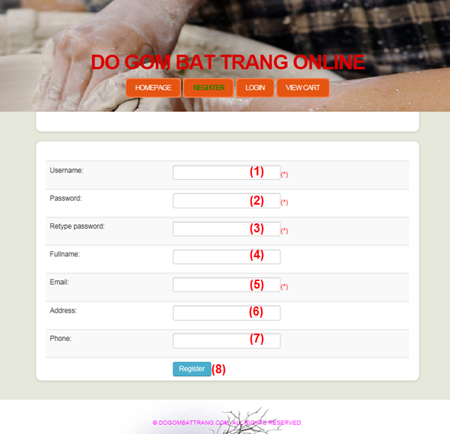

**Figure 3.1-1**: Register page

**Data Fields Definition – Register Page**

|  |  |  |  |  |  |  |
| --- | --- | --- | --- | --- | --- | --- |
| **Field name** | **Description** | **Read**  **Only** | **Mandatory** | **Control Type** | **Data Type** | **Length** |
| 1. “Username” field | Guest must fill his/her username in textbox | N/A | Y | Textbox | Text | - |
| 1. “Password” field | Guest must fill his/her password in textbox | N/A | Y | Textbox | Password | - |
| 1. “Re-type” field | Guest must re-fill his/her password in textbox | N/A | Y | Textbox | Text | - |
| 1. “Fullname” field | Guest can fill this field or not | N/A | N | Textbox | Text | - |
| 1. “Email” field | Guest must fill his/her Family Name in textbox | N/A | Y | Textbox | Text | - |
| 1. “Address” field | Guest must fill his/her Middle Name in textbox | N/A | N | Textbox | Text | - |
| 1. “Phone” field | Guest must fill his/her Given Name in textbox | N/A | N | Textbox | Text | >=8, <=10 |

**Buttons / Hyper Links – Register Page**

|  |  |  |  |  |
| --- | --- | --- | --- | --- |
| **Function** | **Description** | **Available Criteria** | **Validations** | **Outcome** |
| 1. “Register” button | Clicked to save the information for registering | Always available | Check all the constraints as mentioned above | Navigate to “Login” page |

## <Guest>Login

#### Use Case Diagram



#### Use Case Specification

|  |  |  |  |  |
| --- | --- | --- | --- | --- |
| **USE CASE - Login SPECIFICATION** | | | | |
| **Use-case No**. | UC002 | **Use-case Version** | | 1.0 |
| **Use-case Name** | Login | | | |
| **Author** | MinhTN | | | |
| **Date** | 27/11/2012 | **Priority** | Normal | |
| **Actor**:  Guest  **Summary**:  A customer who wants to buy products on OCS must login into the system.  An admin who wants to manage the inventory must login into the system.  **Goal**:  Users can use the system in the way they want after log in.  **Triggers**:  User accesses website’s Home page and clicks “Login” button  **Preconditions**:  User must have an account in the system  **Post** **Conditions**:  After logging in, user moves to website’s Home page with the information that he/she has logged in successfully (his/her username is showed on the website)  **Main Success Scenario:**   |  |  |  | | --- | --- | --- | | **Step** | **Actor Action** | **System Response** | | 1 | Accesses OCS Home page | Shows the interface of home page | | 2 | Clicks “Login” button | Displays login form | | 3 | Fills “Username” and “Password” fields and clicks “Login” | Checks the username and password of user.  Logs user into the system.  Navigates to website’s Home page with username is showed |   **Alternative Scenario:**   |  |  |  | | --- | --- | --- | | Step | Actor Action | System Response | | 1 | *Same as Main Success Scenario.* | | | 2 | *Same as Main Success Scenario.* | | | 3 | Clicks “Register” link | Shows the Register page |   **Exceptions:**   |  |  |  | | --- | --- | --- | | Step | Actor Action | System Response | | 1 | *Same as Main Success Scenario.* | | | 2 | *Same as Main Success Scenario.* | | | 3 | Enters invalid (not registered username, wrong password) data and clicks “Login” | Shows “Username or password is invalid” message.  Moves cursor to the username control. |   **Relationships**:  Register Use Case  **Business Rules**:  Guest who wants to buy products in OCS must login the system. | | | | |
| **Description**:  The user must registered an account before, and have to enter correct (match with password stored in the system) in order to log into the system.  When user logins the system successfully, he/she can use the correlative functions of User role | | | | |

#### Screen

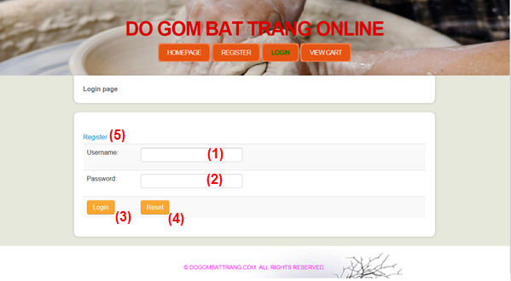

**Figure 3.2-1**: Login page

**Data Fields Definition – Login Page**

|  |  |  |  |  |  |  |
| --- | --- | --- | --- | --- | --- | --- |
| **Field name** | **Description** | **Read**  **Only** | **Mandatory** | **Control Type** | **Data Type** | **Length** |
| 1. “Username” field | Fill the username of account | N | Y | Textbox | Text | - |
| 1. “Password” field | Fill the password of account | N | Y | Textbox | Password | - |

**Buttons / Hyper Links – Login Page**

|  |  |  |  |  |
| --- | --- | --- | --- | --- |
| **Function** | **Description** | **Available Criteria** | **Validations** | **Outcome** |
| 1. “Login” button | Click “Login” button to login the system | Always Available | Check the username and password of account in the system | Moves to website’s Home page |
| 1. “Reset” button | Click “Reset” button to clear fields | Always Available | No validation | Clears input in fields |
| 1. “Register” link | Click “Register” button to register | Always Available | No validation | Moves to Register Page |

## <Guest> View Products

#### Use Case Diagram



#### Use Case Specification

|  |  |  |  |  |
| --- | --- | --- | --- | --- |
| **USE CASE - View Products SPECIFICATION** | | | | |
| **Use-case No.** | UC003 | **Use-case Version** | | 1.0 |
| **Use-case Name** | View Products | | | |
| **Author** | ThangQG | | | |
| **Date** | 28/11/2012 | **Priority** | High | |
| **Actor:**  Guest, User, Admin  **Summary:**  When people visit our website, they can view all products’ information in home page  **Goal:**  View all products  **Triggers:**  User accesses website’s Home page  **Preconditions:**  Home page is loaded successfully.  **Post Conditions:**  All products are showed on home page.  **Main Success Scenario:**   |  |  |  | | --- | --- | --- | | Step | Actor Action | System Response | | 1 | Accesses to OCS home page | Shows all product’s information: image, name and price |   **Alternative Scenario:**  N/A  **Exceptions:**  N/A  **Relationships:**  View product detail use case, Add product to Cart Use case, Search product Use case  **Business Rules:**  Show products’ information on the screen: image, name, price | | | | |

**Screens**

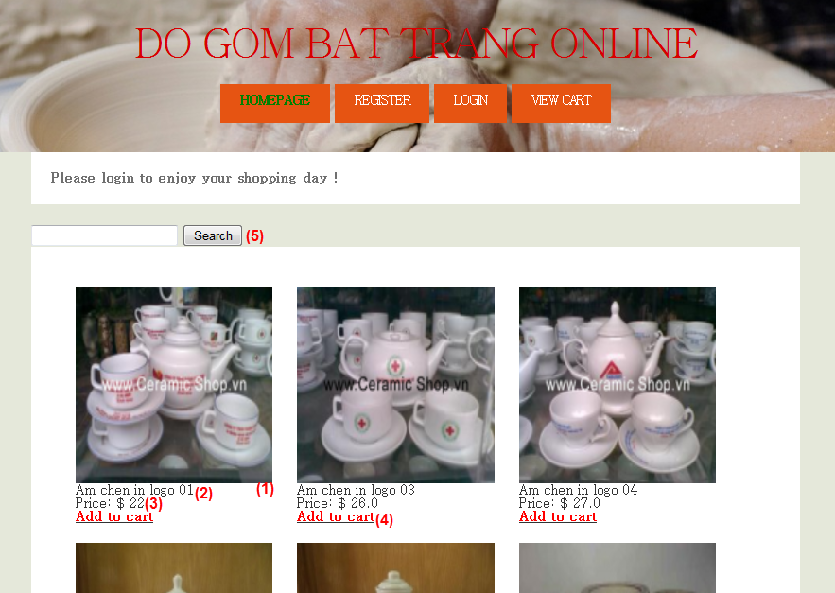

**Figure 3.3‑2** Home page

**Data Fields Definition – Home page**

|  |  |  |  |  |  |  |
| --- | --- | --- | --- | --- | --- | --- |
| **Field name** | **Description** | **Read Only** | **Mandatory** | **Control Type** | **Data Type** | **Length** |
| 1. “Image” field | Image of product | N/A | Y | Image | Image | >0 |
| 1. “Product Name” field | A label contains product name | N/A | Y | Label | String | >=6, <=30 |
| 1. “Price” field | A label contains price of product | N/A | N | Label | String | >0 |

**Buttons / Hyper Links – Home Page**

|  |  |  |  |  |
| --- | --- | --- | --- | --- |
| **Function** | **Description** | **Available Criteria** | **Validations** | **Outcome** |
| 1. “Add to cart” link | Clicked to add this product to Cart | Always available with User & Admin | N/A | Success message box: “Product is added to cart” |
| 1. “Search” button | Clicked to search products | Always available | N/A | Show specific products |

## <Guest> View Product Detail

#### Use Case Diagram



#### Use Case Specification

|  |  |  |  |  |
| --- | --- | --- | --- | --- |
| **USE CASE - View Product Details SPECIFICATION** | | | | |
| **Use-case No.** | UC007 | **Use-case Version** | | 1.0 |
| **Use-case Name** | View Product Detail | | | |
| **Author** | ThangQG | | | |
| **Date** | 28/11/2012 | **Priority** | Normal | |
| **Actor:**  Guest, User, Admin  **Summary:**  When people visit our website, they can view product ‘s details: image, name, price and description.  **Goal:**  View product’s information  **Triggers:**  Users click on any product image to view product information.  **Preconditions:**  N/A  **Post Conditions:**  Product information will be shown in product detail page  **Main Success Scenario:**   |  |  |  | | --- | --- | --- | | **Step** | **Actor Action** | **System Response** | | 1 | Clicks on product image | Gets basic information about this product and shows in the product detail page |   **Alternative Scenario:**  N/A  **Exceptions:**  N/A  **Relationships:**  Add product to cart Use case  **Business Rules:**  User can view more information of product in Product Detail page | | | | |

**Screens**

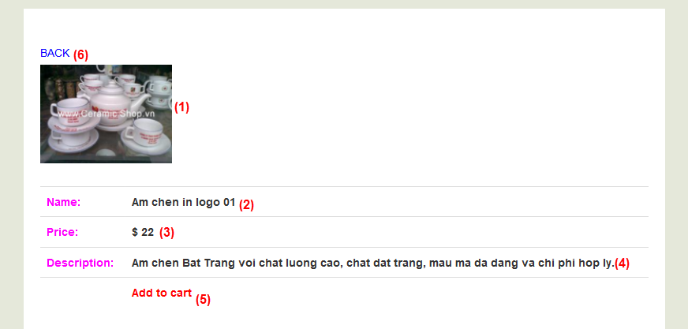

**Figure 3.4‑1** Product Detail page

**Data Fields Definition –Product Detail Page**

|  |  |  |  |  |  |  |
| --- | --- | --- | --- | --- | --- | --- |
| **Field name** | **Description** | **Read Only** | **Mandatory** | **Control Type** | **Data Type** | **Length** |
| 1. “Image” field | Image of product | N/A | Y | Image | Image | >0 |
| 1. “Product Name” field | A label contains product name | N/A | Y | Label | String | >=6, <=30 |
| 1. “Price” field | A label contains price of product | N/A | Y | Label | String | >0 |
| 1. “Description” field | A label contains description of product | N/A | Y | Label | String | >10,  <1000 |

**Buttons / Hyper Links –Product Detail Page**

|  |  |  |  |  |
| --- | --- | --- | --- | --- |
| **Function** | **Description** | **Available Criteria** | **Validations** | **Outcome** |
| 1. “Add to cart” link | Clicked to add this product to Cart | Always available with User & Admin | N/A | Success message box: “Product is added to cart” |
| 1. “Back” button | Clicked to back to home page | Always available | N/A | Shows home page |

## <Guest> Search products

#### Use Case Diagram



#### Use Case Specification

|  |  |  |  |  |
| --- | --- | --- | --- | --- |
| **USE CASE - Search Products SPECIFICATION** | | | | |
| **Use-case No.** | UC005 | **Use-case Version** | | 1.0 |
| **Use-case Name** | Search Products | | | |
| **Author** | MinhTN | | | |
| **Date** | 27/11/2012 | **Priority** | Normal | |
| **Actor**:  Guest, User, Admin  **Summary**:  A customer wants to search products by its name  **Goal**:  System displays the desired result  **Triggers**:  Users enter text-search field and click the button “Search” .  **Preconditions**:  Home page is displayed without any errors  **Post Conditions**:  Search results are displayed.  **Main Success Scenario**:   |  |  |  | | --- | --- | --- | | **Step** | **Actor Action** | **System Response** | | 1 | Accesses to Home page | Shows all products | | 2 | User inputs product name to text field and click to “search” button | System will search product(s) by name and show it/them to the screen |   **Alternative Scenario:**  N/A  **Exceptions:**  N/A  **Relationships**:  View product Detail Use case, Add product to Cart Use Case  **Business Rules**:  Users can search products by name | | | | |

#### Screen

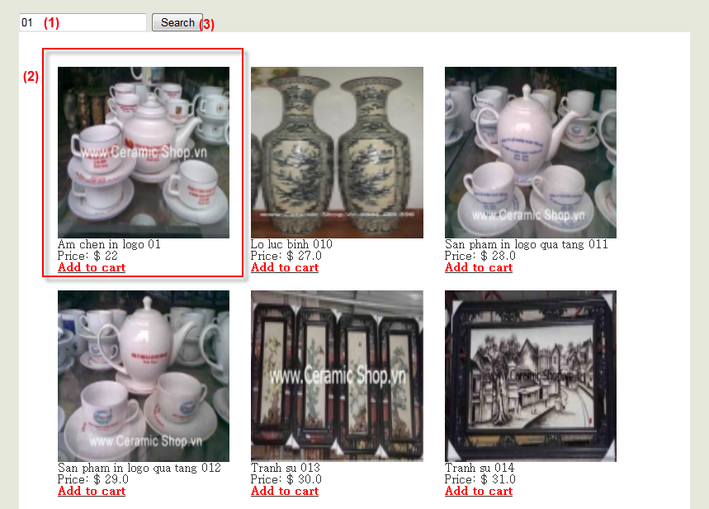

**Figure 3.5-1**: Search Products interface

**Data Fields Definition – Search Products Page**

|  |  |  |  |  |  |  |
| --- | --- | --- | --- | --- | --- | --- |
| **Field name** | **Description** | **Read Only** | **Mandatory** | **Control Type** | **Data Type** | **Length** |
| 1. Text-Search field | Field contains the text-search | N/A | Y | Textbox | Text | >0 |
| 1. Product Info field | Field contains the searched product info | N/A | Y | - | - | - |

**Buttons / Hyper Links – Search Products Page**

|  |  |  |  |  |
| --- | --- | --- | --- | --- |
| **Function** | **Description** | **Available Criteria** | **Validations** | **Outcome** |
| 1. “Search” button | Clicked to search products | Always available | N/A | Shows the specific products’ information |

## <User> Add product to Cart

#### Use Case Diagram



#### Use Case Specification

|  |  |  |  |  |
| --- | --- | --- | --- | --- |
| **USE CASE - Add Product to Cart SPECIFICATION** | | | | |
| **Use-case No.** | UC006 | **Use-case Version** | | 1.0 |
| **Use-case Name** | Add Product to Cart | | | |
| **Author** | ThangQG | | | |
| **Date** | 28/11/2012 | **Priority** | Normal | |
| **Actor:**  User, Admin  **Summary:**  After selecting the product, users can add it to their cart.  **Goal:**  Add a product to cart  **Triggers:**  Users click on “Add to cart” button in the product detail field  **Preconditions:**  N/A  **Post Conditions:**  Product information will be shown in user’s cart  **Main Success Scenario:**   |  |  |  | | --- | --- | --- | | **Step** | **Actor Action** | **System Response** | | 1 | Accesses to home page or product detail | Shows the product information | | 1 | Clicks “Add to cart” button | Shows “The product is added to cart” |   **Alternative Scenario:**  N/A  **Exceptions:**  N/A  **Relationships:**  View Products Use case, View Product Detail Use Case, Search products Use case, Check Out Products in cart Use Case, View Bill Use case  **Business Rules:**  The selected product information is showed in cart | | | | |
| **Description:**  Visitors access to OCS website. They can select the product and add it to cart to buy | | | | |

**Screens**

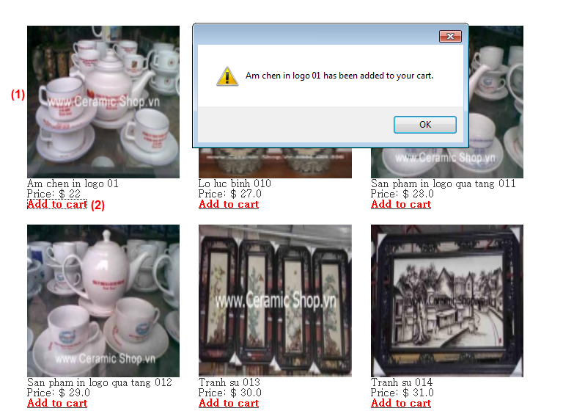

**Figure 3.6‑1** Home page

**Data Fields Definition – Home Page**

|  |  |  |  |  |  |  |
| --- | --- | --- | --- | --- | --- | --- |
| **Field name** | **Description** | **Read Only** | **Mandatory** | **Control Type** | **Data Type** | **Length** |
| 1. Product information field | Field Contains the product’s information | N/A | Y | - | - | - |

**Buttons / Hyper Links – Home Page**

|  |  |  |  |  |
| --- | --- | --- | --- | --- |
| **Function** | **Description** | **Available Criteria** | **Validations** | **Outcome** |
| 1. “Add to cart” link | Clicked to add this product to Cart | Always available with User & Admin | N/A | Success message box |

## <User> View products in Cart

#### Use Case Diagram



#### Use Case Specification

|  |  |  |  |  |
| --- | --- | --- | --- | --- |
| **USE CASE - View cart SPECIFICATION** | | | | |
| **Use-case No**. | UC007 | **Use-case Version** | | 1.0 |
| **Use-case Name** | View Products in Cart | | | |
| **Author** | MinhTN | | | |
| **Date** | 27/11/2012 | **Priority** | Normal | |
| **Actor**:  User, Admin  **Summary**:  After adding products to cart, user can view all products in cart.  **Goal**:  View all products in cart  **Triggers**:  User has added products to cart  **Preconditions**:  Home page is displayed without error  **Post Conditions**:  Users can view the products in cart  **Main Success Scenario**:   |  |  |  | | --- | --- | --- | | **Step** | **Actor Action** | **System Response** | | 1 | User visits Home page | Shows all available products | | 2 | User click to “add to cart” link | Shows message to remind that successful added. | | 3 | User visits View Cart page | Shows products in cart. |   **Alternative Scenario:**  N/A  **Exceptions:**  N/A  **Relationships**:  View Products Use Case, View product detail Use case, Search Product Use case, View Bill Use case, Check out products in cart Use case  **Business Rules**:  User wants to view all products which they have added to cart | | | | |
| **Description:**  Visitors access to OCS website. They can select the product and add it to cart to buy. They click “View Bill” button to manage products in cart | | | | |

#### Screen

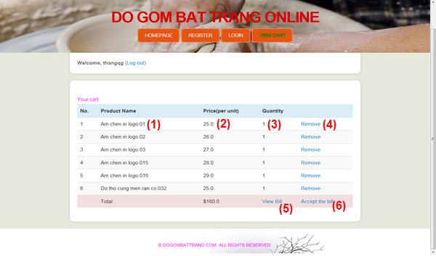

**Figure 3.7-1**: View cart interface

**Data Fields Definition – Cart page**

|  |  |  |  |  |  |  |
| --- | --- | --- | --- | --- | --- | --- |
| **Field name** | **Description** | **Read Only** | **Mandatory** | **Control Type** | **Data Type** | **Length** |
| 1. “Product Name” field | A label contains product name in cart | N/A | Y | Label | String | >=6, <=30 |
| 1. “Price” field | A label contains price of product | N/A | N | Label | String | >0 |
| 1. “Quantity” field | A label contains quantity of product | N/A | N | Label | String | >0 |

**Buttons / Hyper Links – Cart Page**

|  |  |  |  |  |
| --- | --- | --- | --- | --- |
| **Function** | **Description** | **Available Criteria** | **Validations** | **Outcome** |
| 1. “Remove” button | Clicks to remove this product out of Cart | Always available | N/A | This product is removed out of cart |
| 1. “View Bill” button | Clicks to view the bill in pdf file | Always available | N/A | Shows the bills in file pdf |
| 1. “Accepting the bill” | Clicks to accept to check out all products in cart | Always available | N/A | Add all product in cart to Order table in database  Navigates to home page |

## <User> Check out products in Cart

#### Use Case Diagram



#### *Use Case Specification*

|  |  |  |  |  |
| --- | --- | --- | --- | --- |
| **USE CASE - Check Out SPECIFICATION** | | | | |
| **Use-case No**. | UC008 | **Use-case Version** | | 1.0 |
| **Use-case Name** | Check Out In Cart | | | |
| **Author** | ThangQG | | | |
| **Date** | 27/11/2012 | **Priority** | Normal | |
| **Actor**:  User, Admin  **Summary**:  User want to accept to buy products in cart  This function saves information of these products into Order table in database  **Goal**:  User buys products in cart  **Triggers**:  User has to add product(s)  User clicks “Check Out” button on Cart Page  **Preconditions**:  Product(s) must be added to cart already.  **Post Conditions**:  User has bought products in cart.  **Main Success Scenario**:   |  |  |  | | --- | --- | --- | | **Step** | **Actor Action** | **System Response** | | 1 | Accesses home page | Shows the interface of home page | | 2 | Clicks “Add to cart” link in the product’s short information | Shows successful adding message box and save product to cart | | 3 | Clicks “View cart” button in top menu | Shows all products in cart | | 4 | Clicks “Accept Buying” button | Save products’ information to database and redirect to home page |   **Alternative Scenario**:   |  |  |  | | --- | --- | --- | | **Step** | **Actor Action** | **System Response** | | 1 | Same as Main Success Scenario. | | | 2 | Same as Main Success Scenario. | | | 3 | Same as Main Success Scenario. | | | 3 | Clicks “Home Page” button | Navigates backs to home page. |   **Exceptions**:   |  |  |  | | --- | --- | --- | | **Step** | **Actor Action** | **System Response** | | 1 | Same as Main Success Scenario. | | | 2 | Clicks “View cart” button in top menu | Do not show any product in cart | | 3 | Clicks “Accept Buying” button | Shows “Your cart is empty” message box |   **Relationships**:  Remove product in cart Use Case, View Products in cart Use Case  **Business Rules**:  User accepts to buy products in cart. | | | | |
| **Description**:  User adds products to cart and wants to buy them.  This function saves information of these products into Order table in database and user’s cart will be reset. | | | | |

**Screen**

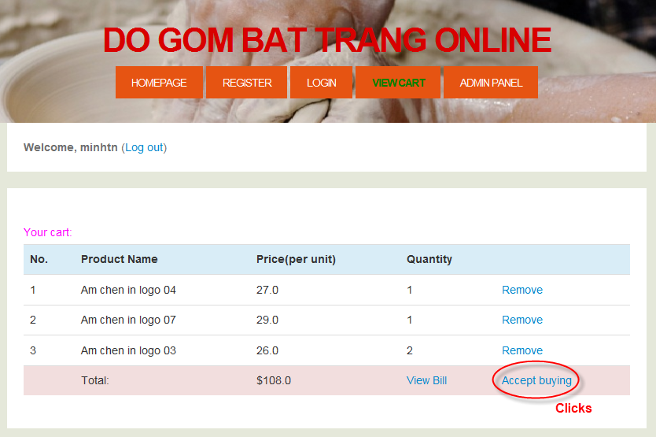

**Figure3.8-1**: Cart page

**Data Fields Definition**

N/A

**Buttons / Hyper Links – Cart Page**

|  |  |  |  |  |
| --- | --- | --- | --- | --- |
| **Function** | **Description** | **Available Criteria** | **Validations** | **Outcome** |
| “Accept Buying” button | Clicked to save the information for registering | Always available | Cart is not empty | Navigate to “Home Page” |

## <Admin> View inventory information

#### Use Case Diagram



#### Use Case Specification

|  |  |  |  |  |
| --- | --- | --- | --- | --- |
| **USE CASE - View Inventory SPECIFICATION** | | | | |
| **Use-case No.** | UC009 | **Use-case Version** | | 1.0 |
| **Use-case Name** | View inventory information | | | |
| **Author** | ThangQG | | | |
| **Date** | 27/11/2012 | **Priority** | Normal | |
| **Actor**:  Admin  **Summary**:  Admin manages products in inventory.  This function shows the information of products in inventory  **Goal**:  Show the information of products in inventory  **Triggers**:  Admin clicks “Admin Panel” button on top menu  **Preconditions**:  Inventory page is displayed without any errors.  **Post Conditions**:  System shows all information on screen.  **Main Success Scenario**:   |  |  |  | | --- | --- | --- | | **Step** | **Actor Action** | **System Response** | | 1 | Accesses home page | Shows the interface of home page | | 2 | Admin clicks to “Admin Panel” button on top menu | Shows all information of inventory in Inventory Page |   **Alternative Scenario**:  N/A  **Exceptions**:  N/A  **Relationships**:  Update product Use Case, Delete product Use case, Update to database Use case, Add Product Use case  **Business Rules**:  Admin can view the information in inventory. | | | | |
| **Description**:  Admin accesses to Inventory Page to see all information in inventory and manages it. | | | | |

**Screen**

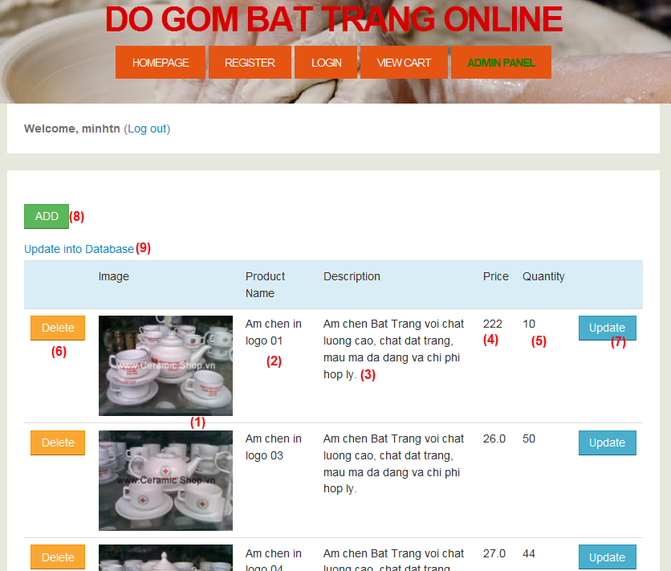

**Figure3.9-1:** Inventory page

**Data Fields Definition – Inventory Page**

|  |  |  |  |  |  |  |
| --- | --- | --- | --- | --- | --- | --- |
| **Field name** | **Description** | **Read**  **Only** | **Mandatory** | **Control Type** | **Data Type** | **Length** |
| 1. “Image” field | Image of product | N/A | Y | Image | Image | >0 |
| 1. “Product Name” field | A label contains product name | N/A | Y | Label | String | >=6, <=30 |
| 1. “Description” field | A label contains description of product | N/A | Y | Label | String | >=10, <=1000 |
| 1. “Price” field | A label contains price of product | N/A | Y | Label | String | >0 |
| 1. “Quantity” field | A label contains quantity of product in inventory | N/A | Y | Label | String | >0 |

**Buttons / Hyper Links – Inventory Page**

|  |  |  |  |  |
| --- | --- | --- | --- | --- |
| Function | Description | Available Criteria | Validations | Outcome |
| 1. “Delete” button | Clicked to delete product’s information in inventory | Always available | N/A | This record is deleted in screen |
| 1. “Update” button | Clicked to move to update inventory page | Always available | N/A | Navigate to update inventory page |
| 1. “Update to database” button | Clicked to update all new information in file xml to database | Always available | N/A | Navigate to home page |
| 1. “Add” button | Clicked to move to add product page | Always available | N/A | Navigate to add product page |

## <Admin> Add New Product

#### Use Case Diagram



#### Use Case Specification

|  |  |  |  |  |
| --- | --- | --- | --- | --- |
| **USE CASE - Add Product SPECIFICATION** | | | | |
| **Use-case No.** | UC010 | **Use-case Version** | | 1.0 |
| **Use-case Name** | Add product | | | |
| **Author** | ThangQG | | | |
| **Date** | 27/11/2012 | **Priority** | Normal | |
| **Actor**:  Admin  **Summary**:  Admin can add new information of product into inventory  **Goal**:  Add new product’s information  **Triggers**:  Admin clicks “Add” button from Inventory page.  **Preconditions**:  Inventory page is displayed without any errors  **Post Conditions**:  Admin adds product into database  **Main Success Scenario**:   |  |  |  | | --- | --- | --- | | **Step** | **Actor Action** | **System Response** | | 1 | Accesses home page | Shows the interface of home page | | 2 | Admin clicks to “Admin Panel” button on top menu | Shows all information of inventory in InventoryPage.jsp | | 3 | Admin clicks to “Add” button | Shows all fields to input: product name, price, description and quantity in add product page | | 4 | Fills mandatory fields and click “Add” button | Do validation, checks conflict and saves data into database.  Navigate to home page. |   **Alternative Scenario**:   |  |  |  | | --- | --- | --- | | **Step** | **Actor Action** | **System Response** | | 1 | Same as Main Success Scenario. | | | 2 | Same as Main Success Scenario. | | | 2 | Same as Main Success Scenario. | | | 3 | Clicks other page button on top menu | Navigates to specific page |   **Exceptions**:   |  |  |  | | --- | --- | --- | | **Step** | **Actor Action** | **System Response** | | 1 | Same as Main Success Scenario. | | | 2 | Same as Main Success Scenario. | | | 3 | Same as Main Success Scenario. | | | 3 | Does not fill all required field, enters invalid data | Displays error messages in specific field |   **Relationships**:  View inventory Use case  **Business** **Rules**:  New Product’s information must be valid | | | | |
| **Description**:  Admin has to provide some information when add new product:   |  |  |  | | --- | --- | --- | | **Field Name** | **Data Type and Constraints** | **Required** | | Product Name | Unicode String  Begins by a letter or an underscore, 6-30 characters | Yes | | Price | Number  More than 9 and  Less than 1 million | Yes | | Description | Unicode String  10-1000 characters | Yes | | Quantity | Number  More than 9 and  Less than 1 million | Yes | | | | | |

**Screen**

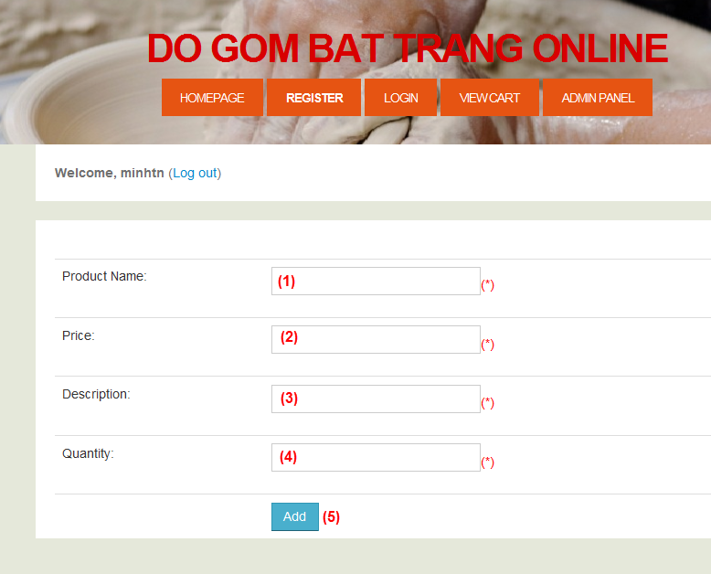

**Figure 3.10-1:** Add Product page

**Data Fields Definition – Add Product Page**

|  |  |  |  |  |  |  |
| --- | --- | --- | --- | --- | --- | --- |
| **Field name** | **Description** | **Read**  **Only** | **Mandatory** | **Control Type** | **Data Type** | **Length** |
| 1. “Product Name” field | Admin must fill product name in textbox | N/A | Y | Textbox | Text | >=6, <=30 |
| 1. “Price” field | Admin must fill price in textbox | N/A | Y | Textbox | Text | >=2, <=6 |
| 1. “Description” field | Admin must fill product description in textbox | N/A | Y | Textbox | Text | >=10, <=1000 |
| 1. “Quantity” field | Admin must fill quantity in textbox | N/A | N | Textbox | Text | >=2, <=6 |

**Buttons / Hyper Links – Add Product Page**

|  |  |  |  |  |
| --- | --- | --- | --- | --- |
| **Function** | **Description** | **Available Criteria** | **Validations** | **Outcome** |
| 1. “Add” button | Clicked to save the information for adding product’s information | Always available | Check all the constraints as mentioned above | Navigate to home page |

## <Admin> Update Product

#### Use Case Diagram



#### Use Case Specification

|  |  |  |  |  |
| --- | --- | --- | --- | --- |
| **USE CASE - Update Product SPECIFICATION** | | | | |
| **Use-case No**. | UC011 | **Use-case Version** | | 1.0 |
| **Use-case Name** | Update product | | | |
| **Author** | ThangQG | | | |
| **Date** | 27/11/2012 | **Priority** | Normal | |
| **Actor**:  Admin  **Summary**:  Admin can update information of product into inventory  **Goal**:  Update product’s information  **Triggers**:  Admin clicks “Update” button from Inventory page.  **Preconditions**:  Update-Inventory page is displayed without any errors  **Post Conditions**:  Admin update product’s information into file xml  **Main Success Scenario**:   |  |  |  | | --- | --- | --- | | **Step** | **Actor Action** | **System Response** | | 1 | Accesses home page | Shows the interface of home page | | 2 | Admin clicks to “Admin Panel” button on top menu | Shows all information of inventory in Inventory Page | | 3 | Admin clicks to “Update” button | Shows information to input fields: product name, price, description and quantity in update inventory page | | 4 | Fills mandatory fields and click “Update” button | Do validation, checks conflict and saves data into inventory.xml and products.xml.  Redirect to inventory page. |   **Alternative Scenario**:   |  |  |  | | --- | --- | --- | | **Step** | **Actor Action** | **System Response** | | 1 | Same as Main Success Scenario. | | | 2 | Same as Main Success Scenario. | | | 2 | Same as Main Success Scenario. | | | 3 | Clicks other page button on top menu | Navigates to specific page |   **Exceptions**:   |  |  |  | | --- | --- | --- | | **Step** | **Actor Action** | **System Response** | | 1 | Same as Main Success Scenario. | | | 2 | Same as Main Success Scenario. | | | 3 | Same as Main Success Scenario. | | | 3 | Does not fill all required field, enters invalid data | Displays error messages in specific field |   **Relationships**:  View Inventory Use case, Delete Use case, Update to database Use case, Add Product Use case  **Business Rules**:  New information of product must be valid | | | | |
| **Description**:  Admin provides some information when update product:   |  |  |  | | --- | --- | --- | | **Field Name** | **Data Type and Constraints** | **Required** | | Product Name | Unicode String  Begins by a letter or an underscore, 6-30 characters | Yes | | Price | Number  More than 9 and  Less than 1 million | Yes | | Description | Unicode String  10-1000 characters | Yes | | Quantity | Number  More than 9 and  Less than 1 million | Yes | | | | | |

**Screen**

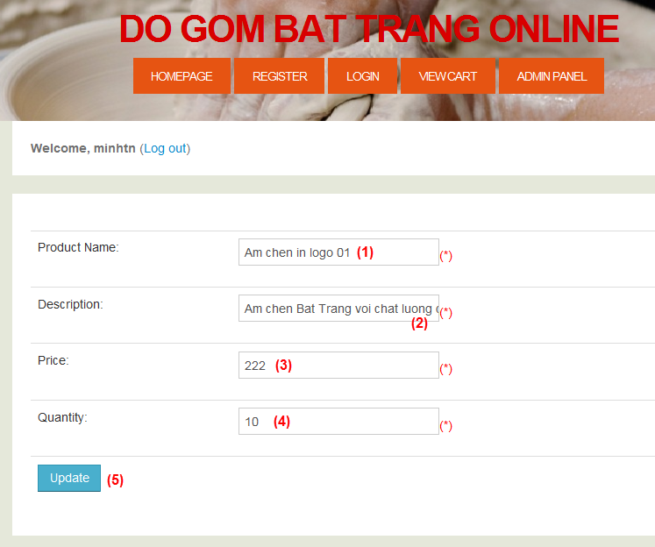

**Figure 3.11‑1** Update Inventory page

**Data Fields Definition – Update Inventory Page**

|  |  |  |  |  |  |  |
| --- | --- | --- | --- | --- | --- | --- |
| **Field name** | **Description** | **Read**  **Only** | **Mandatory** | **Control Type** | **Data Type** | **Length** |
| 1. “Product Name” field | Admin can fill new product name in textbox | N/A | Y | Textbox | Text | >=6, <=30 |
| 1. “Price” field | Admin can fill new price in textbox | N/A | Y | Textbox | Text | >=2, <=6 |
| 1. “Description” field | Admin can fill new product description in textbox | N/A | Y | Textbox | Text | >=10, <=1000 |
| 1. “Quantity” field | Admin can fill new quantity in textbox | N/A | N | Textbox | Text | >=2, <=6 |

**Buttons / Hyper Links – Update Inventory Page**

|  |  |  |  |  |
| --- | --- | --- | --- | --- |
| **Function** | **Description** | **Available Criteria** | **Validations** | **Outcome** |
| 1. “Update” button | Clicked to save the information of product to 2 file xml (inventory.xml & products.xml) | Always available | Check all the constraints as mentioned above | Navigate to Inventory page |

## <Admin> Delete Product

#### Use Case Diagram



#### Use Case Specification

|  |  |  |  |  |
| --- | --- | --- | --- | --- |
| **USE CASE - Delete Product SPECIFICATION** | | | | |
| **Use-case No**. | UC012 | **Use-case Version** | | 1.0 |
| **Use-case Name** | Delete product | | | |
| **Author** | ThangQG | | | |
| **Date** | 27/11/2012 | **Priority** | Normal | |
| **Actor**:  Guest  **Summary**:  Admin can delete the product in inventory  **Goal**:  Delete product’s info  **Triggers**:  Click “Delete” button from Inventory page.  **Preconditions**:  Inventory page is displayed without any errors  **Post Conditions**:  Delete the specific product’s info in file xml  **Main Success Scenario**:   |  |  |  | | --- | --- | --- | | **Step** | **Actor Action** | **System Response** | | 1 | Accesses home page | Shows the interface of home page | | 2 | Admin clicks to “Admin Panel” button on top menu | Shows all information of inventory in Inventory Page | | 3 | Click “Delete” button in specific record product | Delete product information in products.xml and inventory.xml |   **Alternative Scenario**:   |  |  |  | | --- | --- | --- | | **Step** | **Actor Action** | **System Response** | | 1 | Same as Main Success Scenario. | | | 2 | Same as Main Success Scenario. | | | 3 | Clicks other button on top menu | Navigate the specific page. |   **Exceptions**:  N/A  **Relationships**:  N/A  **Business Rules**:  Delete product’s info in inventory.xml and products.xml | | | | |
| **Description**:  Admin deletes the product in Inventory page. System will delete this node information in file xml. | | | | |

**Screen**

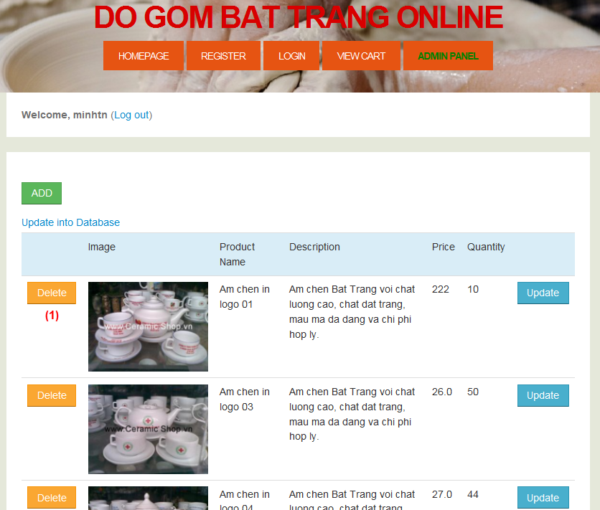

**Figure 3.12-1:** Inventory page

**Data Fields Definition – Inventory Page**

N/A

**Buttons / Hyper Links – Inventory Page**

|  |  |  |  |  |
| --- | --- | --- | --- | --- |
| **Function** | **Description** | **Available Criteria** | **Validations** | **Outcome** |
| 1. “Delete” button | Clicked to delete the information of product in products.xml & inventory.xml | Always available | N/A | Redirect to inventory page |

## <Admin> Update to Database

#### Use Case Diagram



#### Use Case Specification

|  |  |  |  |  |
| --- | --- | --- | --- | --- |
| **USE CASE - Update to Database SPECIFICATION** | | | | |
| **Use-case No.** | UC012 | **Use-case Version** | | 1.0 |
| **Use-case Name** | Update to Database | | | |
| **Author** | ThangQG | | | |
| **Date** | 27/11/2012 | **Priority** | Normal | |
| **Actor**:  Admin  **Summary**:  Update the information in inventory.xml and products.xml to database  **Goal**:  Update the information of inventory to database  **Triggers**:  Admin clicks “Update to database” from Inventory page.  **Preconditions**:  Inventory page is displayed without any errors  **Post Conditions**:  Update the information of inventory in file xml to database  **Main Success Scenario**:   |  |  |  | | --- | --- | --- | | **Step** | **Actor Action** | **System Response** | | 1 | Accesses home page | Shows the interface of home page | | 2 | Admin clicks to “Admin Panel” button on top menu | Shows all information of inventory in Inventory Page | | 3 | Click “Update to database” button | Update information in products.xml and inventory.xml to database (Inventory table & Product table) |   **Alternative Scenario**:   |  |  |  | | --- | --- | --- | | **Step** | **Actor Action** | **System Response** | | 1 | Same as Main Success Scenario. | | | 2 | Same as Main Success Scenario. | | | 3 | Clicks other button | Move to specific page |   **Exceptions**:  N/A  **Relationships**:  Update Product Use case, Delete Product Use case  **Business Rules**:  Update the information of inventory in file xml to database | | | | |
| **Description**:  After delete and update the product in inventory, admin must update to database. This function will help admin to do **this** action | | | | |

**Screen**

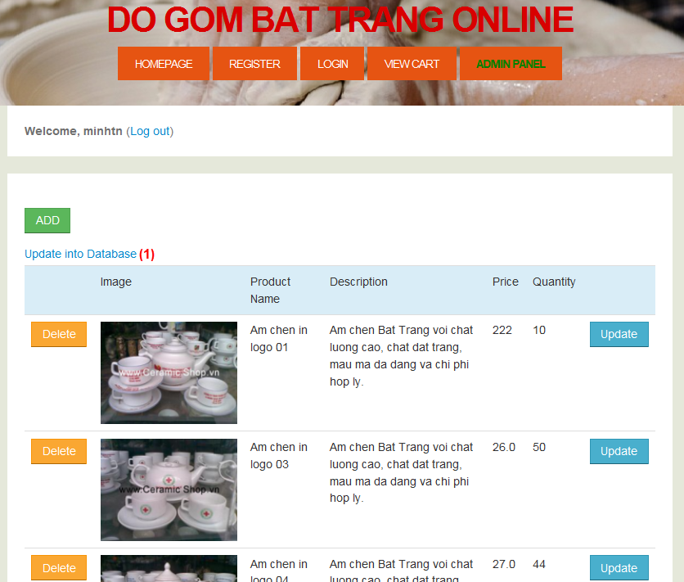

**Figure 3.13-1:** Inventory page

**Data Fields Definition – Inventory Page**

N/A

**Buttons / Hyper Links – Inventory Page**

|  |  |  |  |  |
| --- | --- | --- | --- | --- |
| **Function** | **Description** | **Available Criteria** | **Validations** | **Outcome** |
| 1. “Update to database” button | Clicked to save the information in file xml to database | Always available | N/A | Navigate to home page |

# Sequence Diagram:

## <Guest> Register



**Figure 4.1-1:** Register Sequence Diagram

## <Guest> Login

**Figure 4.2-1:** Login Sequence Diagram

## <Guest> View Products



**Figure 4.3-1:** View Products Sequence Diagram

## <Guest> Search products



**Figure 4.4-1:** Search Products Sequence Diagram

## <User> View products in Cart

**Figure 4.5-1:** View Products in Cart Sequence Diagram

## <User> View Bill in PDF



**Figure 4.6-1:** View Bill in PDF Sequence Diagram

## <User> Check out products in Cart



**Figure 4.7-1:** Check Out in Cart Sequence Diagram

## <Admin> View inventory information



**Figure 4.8-1:** View Inventory Sequence Diagram

## <Admin> Add New Product

**Figure 4.9-1:** Add new Product Sequence Diagram

## <Admin> Update Product



**Figure 4.10-1:** Update Product Sequence Diagram

## <Admin> Delete Product



**Figure 4.11-1:** Delete Product Sequence Diagram

## <Admin> Update to Database



**Figure 4.12-1:** Update to Database Sequence Diagram

# NON-FUNCTIONAL Requirements

## Reliability

The system shall never crash or hang, other than as the result of an operating system or network error.

* Mean Time Between Failures (MTBF): The acceptable failure is once a year. The failure should not be because of the database, or else the data may be lost and cannot be recovered.
* Mean Time To Repair (MTTR): When the failure occurs, it should take at least time as possible to repair. The acceptable mean time for a particular failure must be least than 8 hours.
* Maximum Bugs or Defect Rate: 1-2bugs/KLOC

## Availability

The server shall be working 24/7. When the system go in under-maintenance, the page will display that ‘the website is not available that that moment. Pleased come back in some hours.’.

## Security

There are no specific security and privacy requirements.

## Maintainability

All code shall be fully documented. All program files shall include comments concerning authorship and date of last change.

The code shall be modular to permit future modifications.

## Portability

The software shall be designed to run on Web platform.

## Performance

This is the system’s performance characteristics:

* Throughput: 1000 transactions per second.
* Capacity: 200 customers a time.
* Response time for a transaction:
  + Average: 1 second
  + Maximum: 5 seconds